**REAL-TIME RIVER WATER QUALITY MONITORING AND CONTROL SYSTEM**

**SPRINT-3**

**NODE-RED FLOW DIAGRAM:**

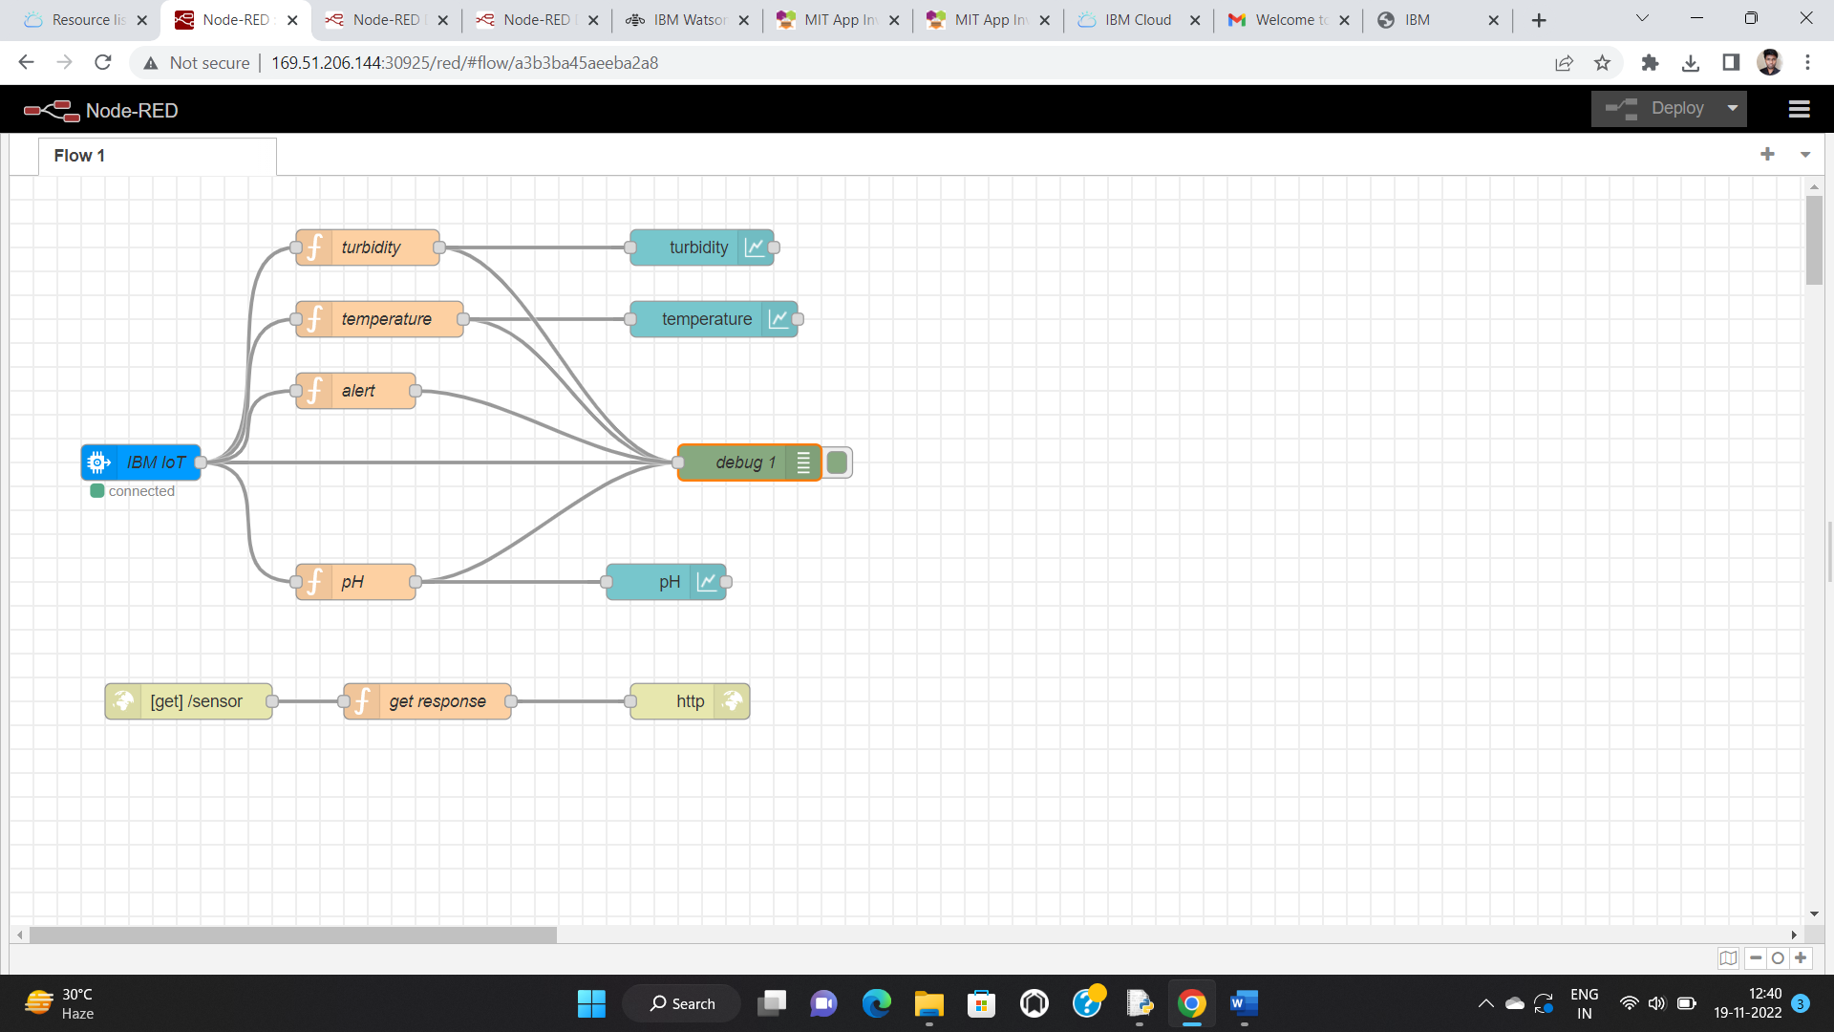

**OUTPUT:**

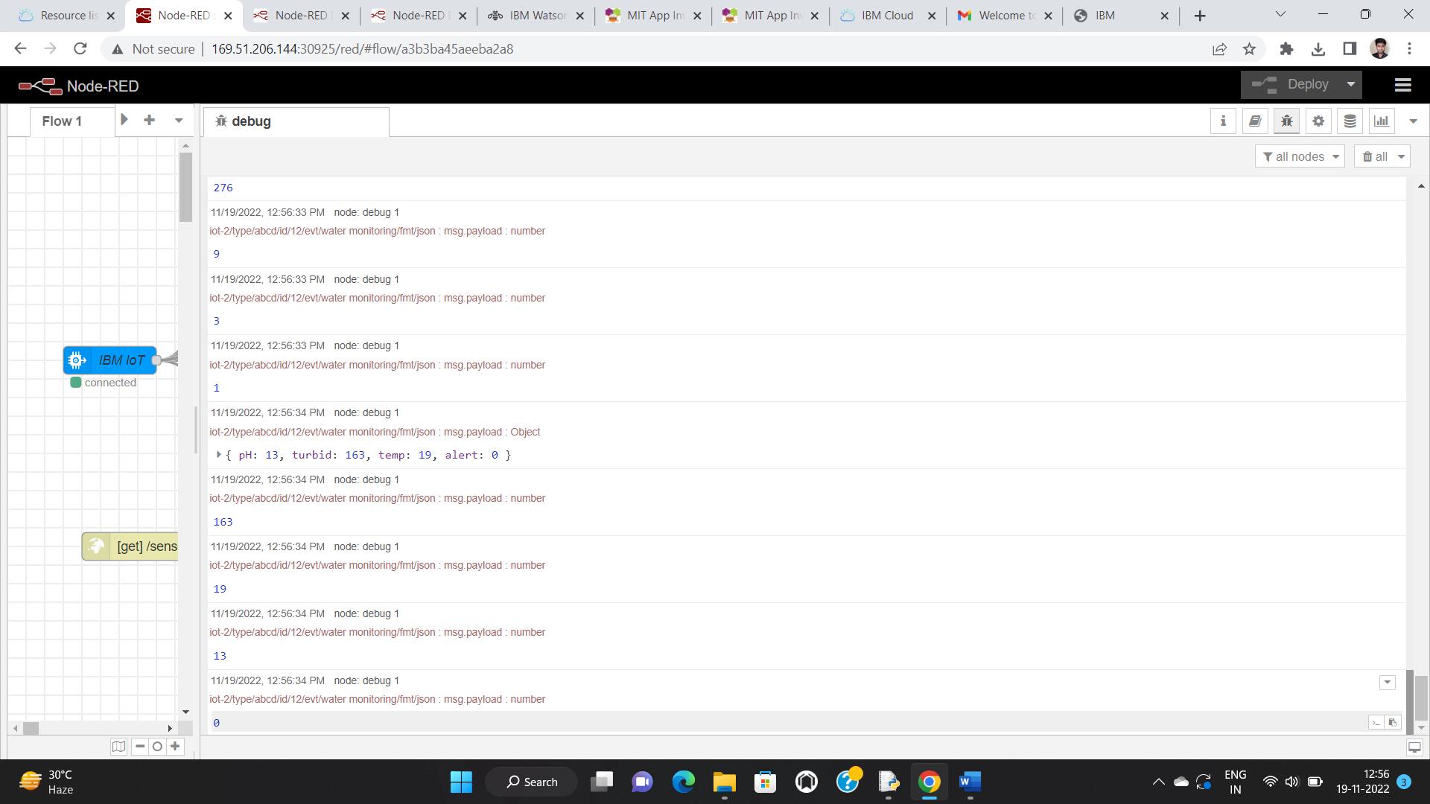

**SOURCE CODE:**

msg.payload = {"temp":global.get('t'),

"pH":global.get('pH'),

"turbid":global.get('tur'),

"alert":global.get('a')}

return msg;

**HTTP REQUEST USING NODE RED:**

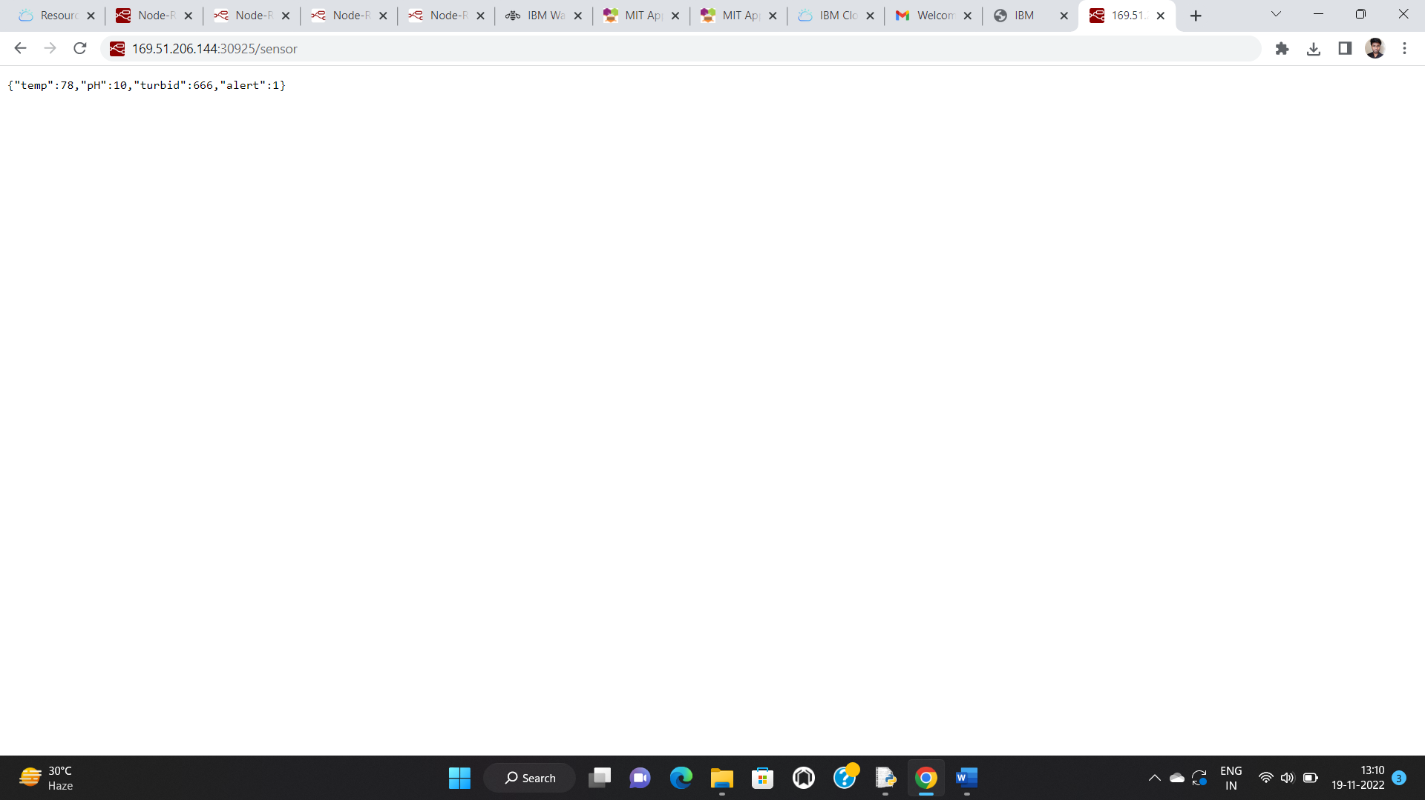

**GENERATE THE OUTPUT FOR RECENT EVENTS:**

